1) What is Power BI?
Ans: Power BI is a Business Analytics and Data Visualization Tool that helps users connect to data, transform it, analyze it, and create interactive reports and dashboards.
It allows organizations to turn raw data into meaningful insights for better decision-making.

2) Who Developed Power BI?
Ans: Power BI was developed by Microsoft.
It was first released in 2015 as part of Microsoft's Business Intelligence (BI) Ecosystem.

3) Why and What is Power BI Used For?
Ans: Organizations generate huge amounts of data every day. Power BI helps to:
- Understand Business Performance
- Track Sales and Revenue
- Monitor KPIs (Key Performance Indicators)
- Identify Trends and Patterns
- Make Data-Driven Decisions
- Create Reports without complex programming
Example:
A retail company can use Power BI to:
- View Monthly Sales
- Find Best-Selling Products
- Analyze Customer Behavior
- Compare Branch Performance
Uses of Power BI:
1. Data Visualization
- Creating Charts, Graphs, Maps, and Dashboards
2. Data Analysis
- Finding Trends, Patterns, and Insights
3. Business Reporting
- Generating Reports for managers and stakeholders
4. Real-Time Monitoring
- Tracking Live Business Data
5. Data Integration
- Connecting and combining data from Multiple Sources
6. Performance Tracking
- Measuring business performance using KPIs
7. Forecasting and Decision Making
- Using Historical Data to predict Future Trends
- Supporting Strategic Decisions

4) What is Business Intelligence (BI)?
Ans: Business Intelligence (BI) is the process of collecting, analyzing, and presenting business data to help organizations make informed decisions.
BI combines:
- Data Collection
- Data Integration
- Data Analysis
- Reporting
- Data Visualization
Example:
BI helps answer questions such as:
- Which products sell the most?
- Which region generates the highest revenue?
- Why did sales drop last month?
BI Tools analyze data and provide actionable insights.
5) Difference Between Excel and Power BI
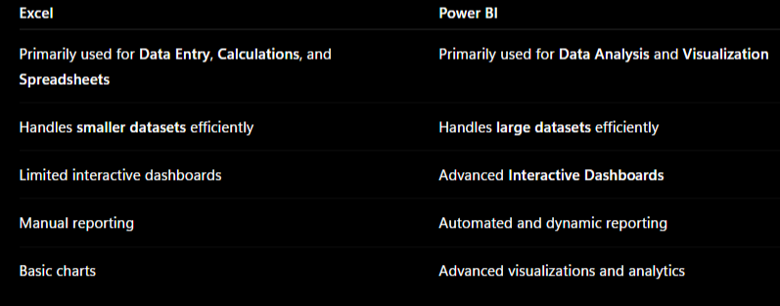
6) What are Data Sources and Connectors in Power BI?
Ans:
A Data Source is where the data comes from.
A Connector is the mechanism Power BI uses to connect to that data source.
File-Based Sources
- Microsoft Excel
- CSV Files
- Text Files
- XML Files
- JSON Files
- PDF Files
Database Sources
- Microsoft SQL Server
- MySQL
- PostgreSQL
- Oracle Database
- SQLite

Cloud Services
- Microsoft Azure
- Google Cloud
- Amazon Web Services (AWS)
Online Services
- SharePoint
- Salesforce
- Google Analytics
Keywords: Data Source, Connector, Excel, SQL Server, MySQL, Azure, AWS, Salesforce

7) What are the Three Views in Power BI?
1. Report View
Purpose: Create and design Reports and Dashboards.
Activities:
- Add Charts
- Add Tables
- Add Maps
- Add Cards
- Create Interactive Visualizations
- Add Slicers and Filters
- Format Reports
Most Used View for Data Analysts

2. Data View
Purpose: Inspect and analyze the actual data loaded into Power BI.
Activities:
- View Rows and Columns
- Create Calculated Columns
- Create DAX Measures
- Validate Data Quality
- Verify imported data
Keywords: Calculated Columns, DAX Measures, Data Validation
3. Model View
Purpose: Manage Relationships between tables.
Activities:
- Create Relationships
- Edit Relationships
- Define Cardinality
  - One-to-One
  - One-to-Many
  - Many-to-Many
- Organize the Data Model
Keywords: Relationships, Cardinality, Data Model

8) What are the Components of Power BI?
1. Power BI Desktop
A Windows Application used to:
- Connect to Data Sources
- Transform and Clean Data
- Create Data Models
- Build Reports and Dashboards
Primary Development Tool

2. Power BI Service
A Cloud-Based Service used to:
- Publish Reports
- Create Dashboards
- Share Insights
- Collaborate
- Schedule Data Refreshes
Accessible through a Web Browser.
3. Power BI Mobile
A Mobile Application used for:
- Viewing Reports and Dashboards
- Monitoring KPIs
- Accessing business data on the go
Available on Android and iOS.
9) What is Power Query?
Power Query is Power BI's data preparation and data cleaning tool. It is used to connect, import, clean, transform, and shape data before loading it into the data model.
Important Points
- Extract, Transform, Load (ETL) tool.
- Connects to Excel, CSV, SQL Server, APIs, Web, etc.
- Cleans messy data before analysis.
- Uses the M Language in the background.
- Reduces manual work by automating data preparation steps.

Examples
- Remove duplicates
- Replace null values
- Split columns
- Merge tables
- Change data types
10) Why Do We Clean Data?
Data cleaning ensures data is accurate, consistent, and reliable for analysis.
Important Points
- Removes errors and duplicates.
- Fixes missing values.
- Standardizes formats.
- Improves report accuracy.
- Prevents incorrect business decisions.
11) What is Data Transformation?
Data Transformation is the process of converting raw data into a usable format for reporting and analysis.
Important Points
- Done mostly in Power Query.
- Improves data quality.
- Makes data analysis easier.
- Creates meaningful structures.
Examples
- Splitting Full Name into First Name and Last Name.
- Converting text dates into proper date format.
- Creating Month and Year columns.
- Pivoting and Unpivoting data.
12) What is Data Modeling?
Data Modeling is the process of organizing tables and defining relationships between them.
Important Points
- Creates connections between tables.
- Improves report performance.
- Enables DAX calculations.
- Avoids duplicate data.

13) What is Relationship in Power BI and its Types?
A relationship connects two tables using a common column.
Types of Relationships
One-to-Many (1:*)
Most Common
One Customer → Many Orders
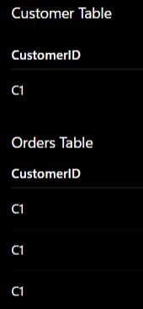

Many-to-One (*:1)
Opposite direction of One-to-Many.
One-to-One (1:1)
One record in Table A matches one record in Table B.
Example:
Employee ↔ Employee Details
Many-to-Many (:)
Multiple records in both tables match.
Example:
Students ↔ Courses
Cross Filter Direction
Single
Filters move one way.
Both
Filters move both ways.
Usually use Single unless needed.
14) What is a Primary Key?
A Primary Key is a column that uniquely identifies each record in a table.
Its usually found in Dimension Tables.
Important Points
- No duplicate values.
- No null values.
- Used to create relationships.
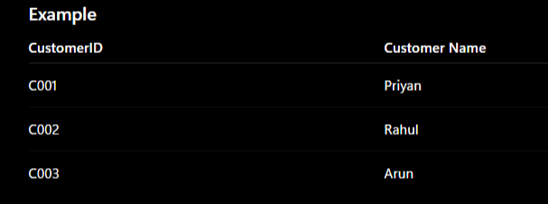

15) Difference Between Report and Dashboard
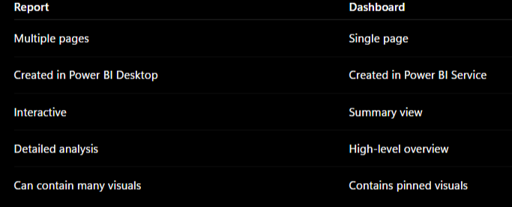
Report Example
- Sales Analysis
- Product Analysis
- Customer Analysis
Dashboard Example
CEO Dashboard showing:
- Total Revenue
- Profit
- Top Product
- Sales Trend

16) Important DAX Functions
SUM()
Adds all values in a column.
Syntax:
Total Sales = SUM(Sales[Sales Amount])
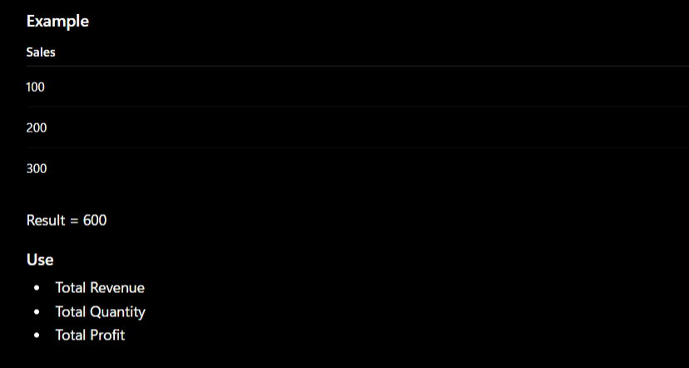
CALCULATE()
Most important DAX function.
Changes the filter context of a calculation.
Syntax:
Total Sales Chennai =
CALCULATE(
SUM(Sales[Sales Amount]),
Sales[City] = "Chennai"
)
Important Points
- Modifies filters.
- Used in almost every advanced DAX measure.
- Works with FILTER(), ALL(), etc.
Example
Calculate sales only for Chennai.

FILTER()
Returns a filtered table.
Syntax:
FILTER(
Sales,
Sales[Amount] > 1000
)

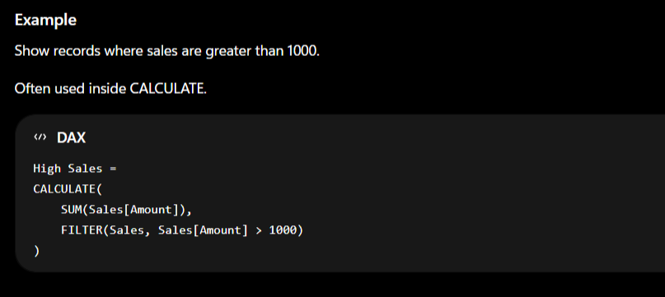
IF()
Performs logical testing.
Syntax:
IF(condition, value_if_true, value_if_false)
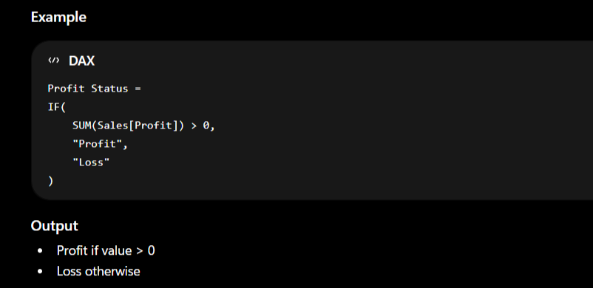
DIVIDE()
Safely performs division.
Syntax:
DIVIDE(numerator, denominator, alternate_result)
Examples:
Profit Margin =
DIVIDE(
SUM(Sales[Profit]),
SUM(Sales[Sales Amount]),
0
)

